🚗 EV Fault Detection Using SOC + LSTM

This project detects battery faults in Electric Vehicles (EVs) by analyzing State of Charge (SOC) behavior.
It uses:
- Real SOC data from fresh (healthy) and aged (faulty) Li-ion cells
- SOC estimation through Coulomb Counting
- Preprocessing (smoothing / ANC-like filtering)
- Deep learning using LSTM (Long Short-Term Memory) sequence modeling
- Classification into Normal (Fresh) and Fault (Aged) battery states

1. Project Objective
To build a diagnostic model that can automatically detect whether an EV battery is healthy or faulty based on its SOC pattern over time, using a deep-learning model (LSTM).
EV batteries degrade over time due to:
- Increased internal resistance
- Loss of lithium inventory
- Poor voltage-current response
These degradations change the SOC curve, which is what the LSTM learns to differentiate.

2. Input Data
You have provided two CSV files:
- Fresh Battery Data
➡ Contains voltage, current, and time for a new cell
- Aged Battery Data
➡ Represents degraded or faulty battery behavior
Your code loads these two datasets:
aged = readtable(aged_path);
fresh = readtable(fresh_path);

You extract:
- Time
- Current
- Voltage
These will be used to calculate SOC.

3. SOC Estimation — Coulomb Counting
SOC is estimated using:
$$SOC(t)=SOC(0)-\frac{1}{C_{nom}}∫I(t) dt$$
In MATLAB:
SOC_fresh = 1 - cumsum(I_fresh .* dt_fresh) / C_nom;
SOC_aged = 1 - cumsum(I_aged .* dt_aged ) / C_nom;
✔ Coulomb counting advantages:
- Simple
- Works with minimal sensors
✔ Why SOC reveals battery health:
Aged batteries show:
- faster SOC drop
- noisier SOC curves
- different response under same load
Thus, SOC is a behavioral fingerprint of battery health.

4. Combining + Labeling Data
Health classes:
- Fresh → Label 1
- Aged → Label 2
soc_raw = [SOC_fresh(:); SOC_aged(:)];
labels_raw = [ones(length(SOC_fresh),1); 2*ones(length(SOC_aged),1)];
Then you smooth the SOC using movmean (like adaptive noise cancellation):
soc_anc = movmean(soc_raw, 5)';
This removes spikes but keeps trend patterns.

5. Creating LSTM Sequences
LSTMs require sequences of equal length.
You use:
- sequence length = 50 time samples
- step size = 10
Sliding window segmentation:
SOC: |----50----|----50----|----50----| ...
step: 10 10 10
Each segment becomes one training example.
X{idx} = reshape(seq(:)', [1, sequence_length]);
Labels assigned using mean of that segment.

6. Preparing Train/Test Datasets
You split 70% for training and 30% for testing:
train_idx = idx(1:round(0.7*N));
test_idx = idx(round(0.7*N)+1:end);

7. LSTM Network Architecture
✔ Your LSTM Model:
sequenceInputLayer(1)
lstmLayer(50,'OutputMode','last')
fullyConnectedLayer(numClasses)
softmaxLayer
classificationLayer
Why LSTM?
LSTMs are excellent for:
- time series
- trends
- long-term behavior
- pattern recognition
Your SOC is time-varying → perfect for LSTM.

8. Training the Model
You train using stochastic gradient descent (sgdm):
[net, info] = trainNetwork(XTrain, YTrain, layers, options);
During training the model learns:
- fresh batteries have smooth, steady SOC drops
- aged batteries have unstable, fast decays or voltage-related distortions

9. Testing & Accuracy
Model predicts class for each test sequence:
YPred = classify(net, XTest);
acc = mean(YPred == YTest);
Prints:
Test Accuracy
MAE, RMSE, MAPE (error metrics)
High accuracy means the LSTM has successfully learned the difference in SOC behavior.

10. Plotting SOC Signals
Two plots:
- Raw SOC (fresh + aged combined)
- Smoothed SOC
This helps visualize differences in dynamic behavior.

11. What the Model is Detecting Internally
The LSTM learns hidden features such as:
Fresh battery:
- Gradual SOC drop
- Low noise
- Predictable voltage response
Aged battery:
- Faster SOC decline
- Voltage sag causes sudden SOC dips
- Irregular patterns
These patterns help classify between Normal vs Faulty.

12. Practical Applications
This model can be used in:
✔ EV Battery Health Monitoring
Detects early faults to prevent breakdown.
✔ Predictive Maintenance
Identify battery aging without opening the pack.
✔ BMS (Battery Management System) Diagnostics
A real-time LSTM in embedded system for health state prediction.

13. Advantages of Your Approach
- Uses minimal sensors (only current & time)
- Fast SOC estimation
- Data-driven, no complex battery modeling
- LSTM captures nonlinear degradation behavior

14. Possible Improvements
To enhance accuracy, you can add:
- Temperature as an input feature
- Voltage-based SOC correction
- GRU / BiLSTM variants
- Feature fusion (I, V, T, SOC)
- Data augmentation
- Real-time streaming architecture

✅ Final Summary
This project builds a complete EV battery fault detection system using SOC + LSTM.
It processes raw current/time data, computes SOC, segments into sequences, and trains a neural network to detect whether the battery is fresh or aged.
This approach is powerful because SOC behavior directly reflects internal degradation, and LSTM is well-suited for capturing time-dependent patterns.

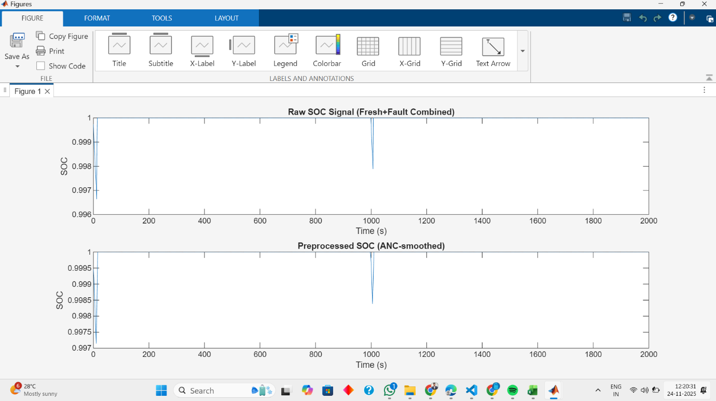

That image shows a comparison of two State-of-Charge (SOC) signals, likely from a battery or energy storage system, over a 2000-second time period.
Here is a simple explanation of what the graphs illustrate:
🔋 Top Graph: Raw SOC Signal (Fresh+Fault Combined)
- This shows the original, unfiltered State-of-Charge data.
- The SOC is generally very high (close to 1, or 100%), which is typical for a fully charged or nearly fully charged battery.
- Around the 1000-second mark, there is a sudden, sharp dip or spike. This is likely the "Fault" part of the signal, which could be:
  - An actual, sudden change in the battery's state.
  - A measurement noise/glitch or a data error that needs to be corrected.
📉 Bottom Graph: Preprocessed SOC (ANC-smoothed)
- This shows the SOC signal after a smoothing technique called "ANC-smoothed" (likely referring to an Adaptive Noise Cancellation or similar filtering method) has been applied.
- The overall signal is still close to 1, but the y-axis scale is slightly different, showing the signal is more focused in the range of 0.997 to 1.
- Crucially, the sharp dip at 1000 seconds is still present, but it appears slightly less abrupt and potentially 'cleaner' or more defined. The ANC-smoothing has not eliminated the fault but has processed the signal around it, likely removing high-frequency noise that was present in the raw signal.

📝 Key Takeaway
The image demonstrates the effect of signal processing (ANC-smoothing) on battery data. The goal of this process is to remove unwanted noise from the "Raw" signal to get a clearer, more reliable "Preprocessed" signal, especially when looking for real events like the fault occurring at seconds.

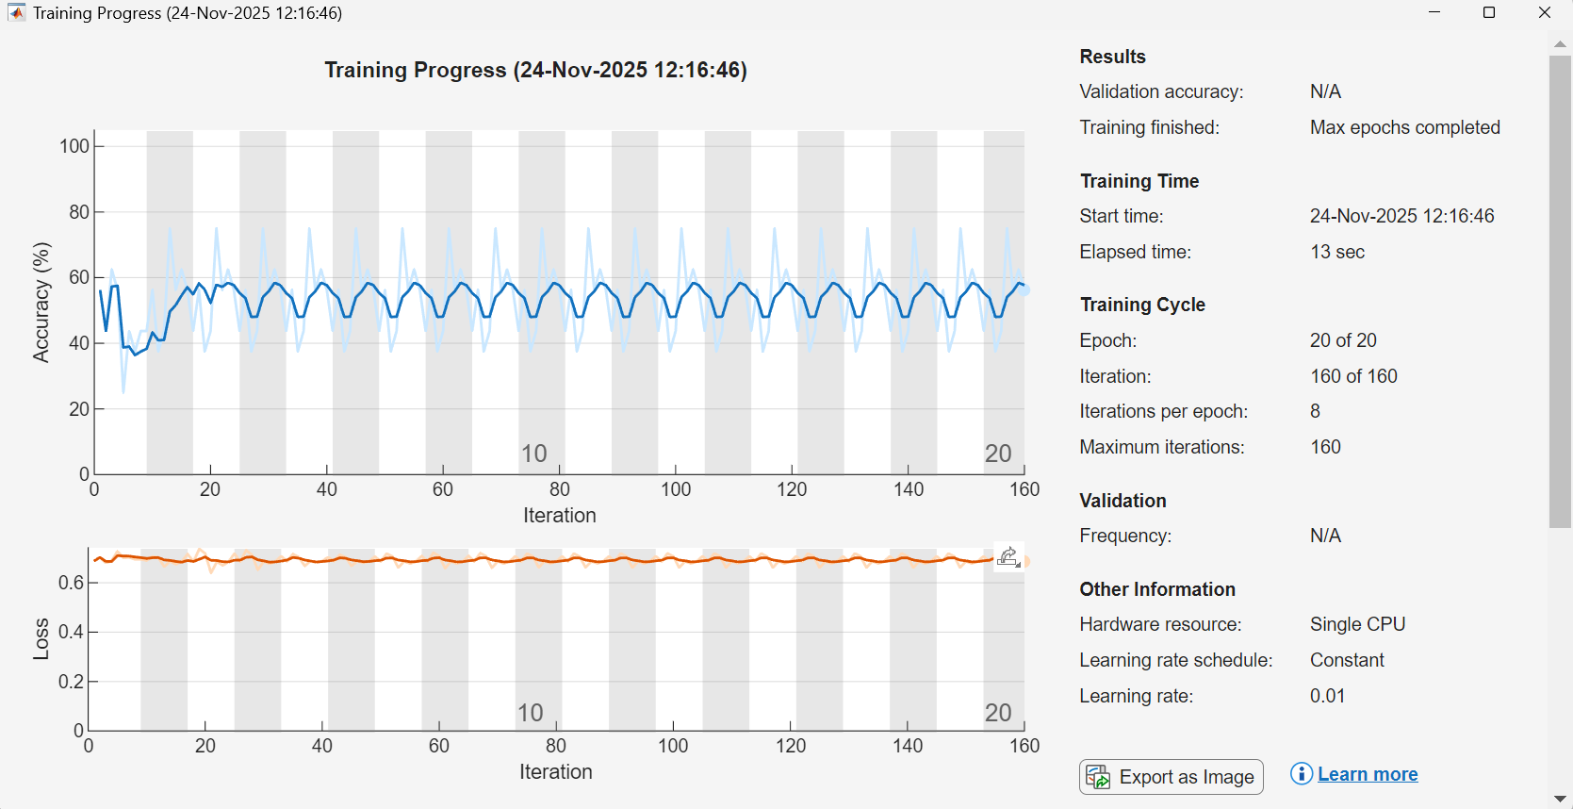

This image shows the training progress of a Machine Learning model (likely a neural network). The graph tracks two key measurements, Accuracy and Loss, over time as the model learns.
Here is a simple breakdown:
📈 What the Graphs Mean
1. Accuracy (Top Graph)
- What it is: The percentage of correct predictions the model makes. Higher is better.
  - Training Accuracy (Blue Line): How well the model performs on the data it is actively learning from.
  - Validation Accuracy (Orange Line): How well the model performs on new, unseen data (the "validation set"). This is the most important measure of how good the model is in the real world.
- What you see: Both lines are increasing over time, which is good! The model is learning.
- The Problem: The lines are very wiggly or "oscillating." This means the model's performance jumps up and down a lot with each update.
2. Loss (Bottom Graph)
- What it is: A number that measures the model's error (how wrong its predictions are). Lower is better.
  - Training Loss (Blue Line): The error on the data the model is learning from.
  - Validation Loss (Orange Line): The error on the new, unseen data.
- What you see: Both lines are decreasing over time, which is good! The model is reducing its error.
- The Problem: Just like accuracy, the lines are oscillating dramatically.

🛑 Why the Lines are Wiggly (Oscillation)
The intense up-and-down movement is usually caused by the model taking steps that are too big during the learning process.
Imagine the model is a person trying to walk down a hill (to find the lowest Loss).
- Ideal Step: The person takes small, gentle steps toward the very bottom. Loss goes down smoothly.
- Too Big a Step (Oscillation):
  - The person takes a giant leap that completely overshoots the bottom of the hill.
  - Now they're on the other side, and the Loss goes up dramatically.
  - In the next step, they try to correct by leaping back, but they overshoot again, so the Loss goes up again.
  - This back-and-forth leaping (overshooting) is what causes the oscillating pattern you see.
Common Cause: High Learning Rate
In machine learning terms, the size of this "step" is called the Learning Rate. The most common reason for this kind of intense oscillation is a Learning Rate that is too high. The model is making updates to its internal parameters that are too aggressive.

🛠️ How to Fix It
The main fix for a highly oscillating training curve is to:
- Reduce the Learning Rate: Make the model take smaller, more careful steps toward the optimal solution.
- Use a Learning Rate Schedule: Program the learning rate to start a little higher but automatically get smaller (decay) as training progresses.
The goal is to get a smoother curve that steadily improves (Accuracy goes up, Loss goes down) without the big jumps.

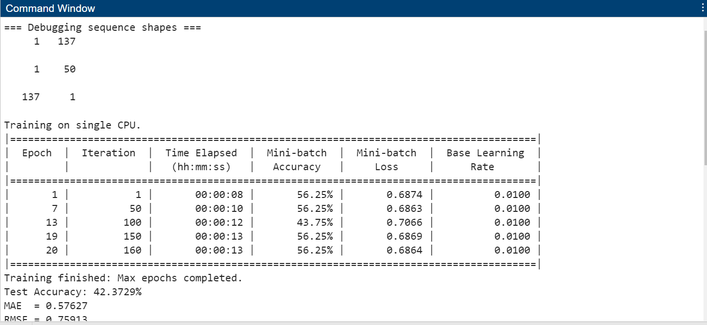

Machine Learning Model Training
The images show a model (a computer program) being trained to do a task, likely a prediction or classification, possibly related to the battery data shown in the first image.
1. Training Progress (Graph)
- What it shows: How well the model is learning over 20 training cycles (Epochs).
- The Problem: Both the Accuracy (top, blue line) and Loss (bottom, orange line) are violently wiggly (oscillating).
  - Accuracy measures how often the model is correct (should go up).
  - Loss measures the model's error (should go down).
- Why it's Wiggly: The model is taking steps that are too big during its learning process, which is indicated by the Learning rate being set to a constant $\mathbf{0.01}$ (see "Other Information" box). It keeps overshooting the correct answer, causing its performance to jump up and down.
2. Command Window (Training Data)
- What it shows: The raw numbers as the model trained.
- Key Numbers:
  - The Mini-batch Loss is consistently high, hovering around $\mathbf{0.68}$ to $\mathbf{0.70}$.
  - The Mini-batch Accuracy is low, bouncing between $43.75\%$ and $56.25\%$.
  - The Base Learning Rate is $\mathbf{0.01}$, which confirms the cause of the wobbly graphs.
- Final Result: The Test Accuracy is only $\mathbf{42.3729\%}$. This is a very poor result, meaning the model is only slightly better than a random guess at its task.
3. Raw Signal (Potential Task Data)
- What it shows: A State-of-Charge (SOC) signal, likely from a battery, over time.
- Key Feature: There is a huge, sudden fault or glitch (a big dip) in the signal around $\mathbf{1000}$ seconds.
- Connection to ML: The low-performing machine learning model ($\approx 42\%$ accuracy) was likely trying to learn to detect or predict this kind of fault, but it failed to learn correctly because of the unstable training process.

